Local Legends Prompt
View the Curse of the Blair Witch Documentary
What are five things the filmmaker uses to make the idea of the Blair Witch a believable one?
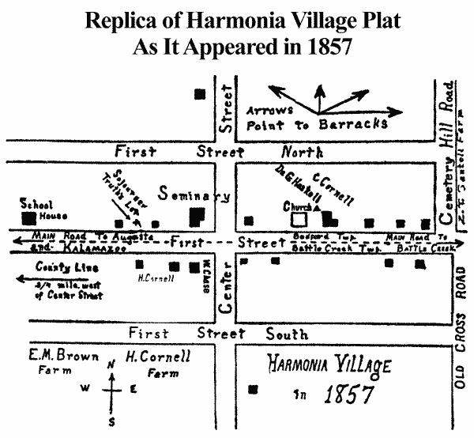

What makes the idea of the
Blair Witch frightening?

In what ways do we “see” the Blair
Witch? How does this contribute to the emotion of the film?

What are some local myths or local places that you could utilize to tell a similar story? Possible examples: Harmonia, Singapore, Seney, The Tower Asylum, The Miner’s Hall, James Island
“They went into the woods to prove true harmony could exist between human beings. What happened next is source of secret controversy that is buried, like the dead, in the past—all but lost to history. Some say the woods were haunted and that Harmonia never stood a chance…”


